For technical trainings regarding SQL please refer to: CCH Tagetik - Trainings\SQL

………………………………………………………………………………………………………………………………………………………………………………………….
Infos:
1-Best Practice(SQL)
Dans un Processus ETL, si nous voulons prendre la data directement dans la base de donnée, alors nous aurons besoin d'une règle SQL.

2-Fichier CSV.
Si le client extrait ses données de la base de donnée dans un fichier CSV.(EXCEl), qui par la suite sera extrait via le ETL, alors nous n'aurons pas besoin de regle SQL.

L'option 2 entraine des inconvénients:
- Le risque que le fichier CSV. Ne soit pas mis à jours
- Rajouter une étapes, soit d'extraire en csv puis apres utiliser l'ETL
………………………………………………………………………………………………………………………………………………………………………………………….

- SQL requests examples (to be used during projects)
Code | 001
Description / Context | Display the content of a staging table. Could be used to display the content of a table fed with extraction data. For example, the transactional data caught during the TB loading. They can be display using this SQL request, as a “Drill-through” for the user.
SQL | SELECT  CAMPO3 AS "ENTITY"  ,CAMPO1 AS "SCENARIO"  ,CAMPO2 AS "PERIOD"  ,CAMPO4 AS "TAGETIK ACCOUNT"  ,CAMPO102 AS "TAGETIK ACCOUNT DESCRIPTION"  ,CAMPO15 AS "SOURCE GL ACCOUNT"  ,CAMPO101 AS "SOURCE GL ACCOUNT DESCRIPTION"  ,CAST(CAMPO8 AS NUMERIC(27,2)) AS "AMOUNT"  FROM MAP_DATI_TRASFORMATI  WHERE  CAMPO3=${$Entity.code}  AND CAMPO1= ${$Scenario.code}  AND CAMPO2=${$Period.code}  AND CAMPO4 IN (SELECT COD_CONTO FROM CONTO WHERE TIPO_CONTO = 'N')  AND COD_MAPPATURA ='01_LIVE'  AND COD_IMPORT = 'TB_LIVE'  UNION ALL  SELECT  'TOTAL' AS "ENTITY"  ,'' AS "SCENARIO"  ,'' AS "PERIOD"  ,'' AS "TAGETIK ACCOUNT"  ,'' AS "TAGETIK ACCOUNT DESCRIPTION"  ,'' AS "SOURCE GL ACCOUNT"  ,'' AS "SOURCE GL ACCOUNT DESCRIPTION"  ,SUM(CAST(CAMPO8 AS NUMERIC(27,2))) AS "AMOUNT"  FROM MAP_DATI_TRASFORMATI  WHERE  CAMPO3=${$Entity.code}  AND CAMPO1= ${$Scenario.code}  AND CAMPO2=${$Period.code}  AND CAMPO4 IN (SELECT COD_CONTO FROM CONTO WHERE TIPO_CONTO = 'N')  AND COD_MAPPATURA ='01_LIVE'  AND COD_IMPORT = 'TB_LIVE'  GROUP BY  CAMPO3

Code | 001 bis
Description / Context | Application of the query 001 to Nutrigroupe BS  XXX List of the columns you want to display  XXX Retrieve data from MAP_DATI_TRANSFORMATI  /!\the structure of MAP_DATI_TRANSFORMATI is not the same for all clients  /!\ Campo# must be updated according the structure of the table  /!\ Sometimes you have to convert the format of the data with the formula CAST (e.g: for the amount below or for the date in the query 001)  XXX UNION ALL and the code below are only to obtain the TOTAL  /!\ keep the same criteria than the yellow part  /!\ adjust the number of '',to obtain the same number of columns determined on the blue part  In the Query do not forget to choose “Drill-Through” as query type  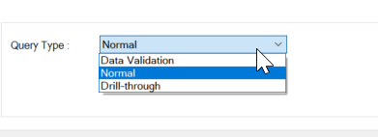  With the layout option there are also some interesting boxes to tick regarding the presentation  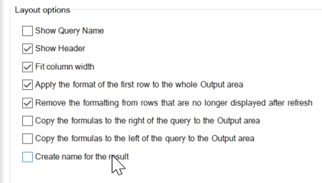
SQL | SELECT  "Master_Account",  "Master_Account_Description",  "Local_GL_Account",  "Local_GL_Description",  amount  FROM (  SELECT campo1 AS "Scenario",  campo2 AS "Period",  campo3 AS "Entity",  campo15 AS "Local_GL_Account",  campo4 AS "Master_Account",  campo102 AS "Master_Account_Description",  campo101 AS "Local_GL_Description",  CAST (REPLACE(campo8,',','.') AS NUMERIC(20,2)) AS amount  FROM map_dati_trasformati  WHERE cod_mappatura='01_LIVE'  AND cod_import='TB_LIVE'  AND campo1=${$Scenario.code}  AND campo2=${$Period.code}  AND campo3=${$Entity.code}  AND campo4=${$Account.code}  ) a  UNION ALL  SELECT 'Total',  '',  '',  '',  SUM(amount) AS amount  FROM (  SELECT CAST (REPLACE(campo8,',','.') AS NUMERIC(20,2)) AS amount  FROM map_dati_trasformati  WHERE cod_mappatura='01_LIVE'  AND cod_import='TB_LIVE'  AND campo1=${$Scenario.code}  AND campo2=${$Period.code}  AND campo3=${$Entity.code}  AND campo4=${$Account.code}  ) a  Result :  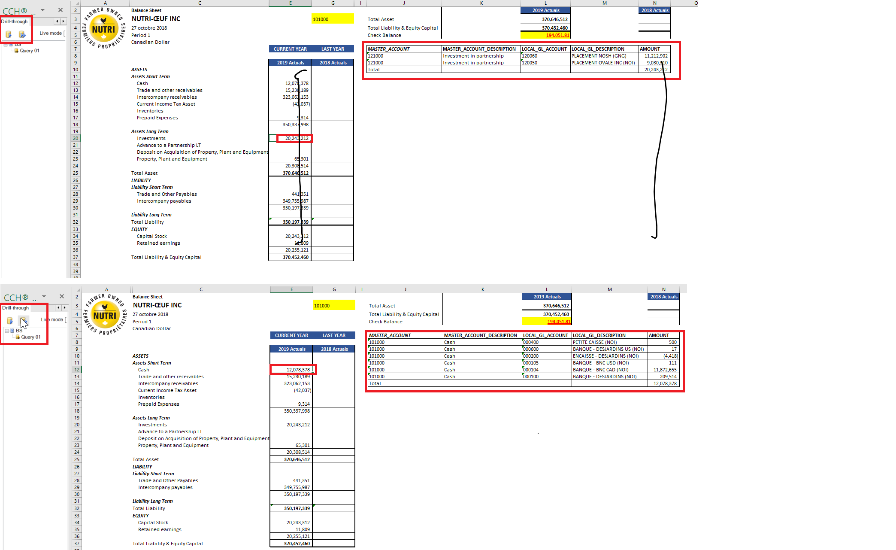

Code | 002
Description / Context | Transactional Details pour une balance sheet: Qui est en fait un drill thought
SQL | SELECT "Local_GL_Account",  "Local_GL_Description",  "Master_Account",  "Invoice_Number",  "Invoice_Date",  "Customer/Supplier",  amount  FROM (  SELECT campo1 AS "Year",  campo14 AS "Scenario",  campo2 AS "Month",  campo3 AS "Entity",  campo4 AS "Local_GL_Account",  campo15 AS "Master_Account",  campo5 AS "Local_GL_Description",  campo6 AS "Cost_Center",  campo7 AS "Product",  campo11 AS "Customer/Supplier",  campo9 AS "Invoice_Number",  CASE WHEN LENGTH(campo10) > 0 THEN  TO_CHAR(TO_DATE('01011900','MMDDYYYY')+TO_NUMBER(campo10,'99999')*INTERVAL '1 Day', 'MM/DD/YYYY')  ELSE ''  END AS "Invoice_Date",  campo11 AS "Supplier",  CAST (REPLACE(campo12,',','.') AS NUMERIC(20,2)) AS amount  FROM map_dati_trasformati  WHERE cod_mappatura='05'  AND cod_import='010'  AND campo1='2018'  AND campo2='12'  AND campo3=${$Entity.code}  AND campo6='CC_500'  AND campo7='PD_500'  AND campo8='CM_500'  AND campo15=${$Account.code}  AND campo14= ${$Scenario.code}  ) a  UNION ALL  SELECT 'Total',  '',  '',  '',  '',  '',  SUM(amount) AS amount  FROM (  SELECT CAST (REPLACE(campo12,',','.') AS NUMERIC(20,2)) AS amount  FROM map_dati_trasformati  WHERE cod_mappatura='05'  AND cod_import='010'  AND campo1='2018'  AND campo2='12'  AND campo3=${$Entity.code}  AND campo6='CC_500'  AND campo7='PD_500'  AND campo8='CM_500'  AND campo15=${$Account.code}  AND campo14= ${$Scenario.code}  ) a

Code | 003
Description / Context | Display a specific FX rate for Period/Scenario choosen
SQL | SELECT B.CAMBIO_FINALE  FROM AZIENDA A FULL OUTER JOIN DATI_CAMBIO B  ON A.COD_VALUTA = B.COD_VALUTA  WHERE  COD_SCENARIO=${$SCENARIO.CODE}  AND COD_PERIODO=${$PERIOD.CODE}  AND COD_AZIENDA=${$ENTITY.CODE}

Code | 004
Description / Context | Information all table :
SQL | SELECT  *  FROM  INFORMATION_SCHEMA.TABLES

Code | 005
Description / Context | To display the first 10 rows of a table. Could be used to know what are the fields and data of a table without displaying the whole table
SQL | SELECT *  FROM MAP_DATI_TRASFORMATI  FETCH FIRST 10 ROWS ONLY

Code | 006
Description / Context | Example to join more than two tables with personalize descriptions and filters
SQL | SELECT  T2.cod_azienda as "Code Entity",  T2.desc_azienda0 as "Entity",  T6.desc_conto_eleger0,  T5.cod_conto as "Account",  T5.desc_conto0 as "Account desc",  T3.cod_periodo as "Period",  T4.cod_scenario as "Scenario"  From  DATI_SALDI_LORDI T1  join AZIENDA T2 on T2.cod_azienda = T1.cod_azienda  join PERIODO T3 on T3.cod_periodo = T1.cod_periodo  join SCENARIO T4 on T4.cod_scenario = T1.cod_scenario  join CONTO T5 on T5.cod_conto = T1.cod_conto  join CONTO_GERARCHIA T6 on T6.cod_conto_gerarchia = T6.cod_conto_gerarchia  join CATEGORIA T7 on T7.cod_categoria = T1.cod_categoria  where  T2.cod_azienda like 'NOI'  and T3.cod_periodo like '01'  and T4.cod_scenario like '2019ACT'  and T7.cod_categoria like '$AMOUNT'

Code | 007
Description / Context | Information all table used for AIH:
SQL | SELECT  *  FROM  INFORMATION_SCHEMA.TABLES  WHERE TABLE_NAME LIKE 'aw%'

Code | 008
Description / Context | Enrichment SQL instruction (Campo1 = Entity dimension)
SQL | SELECT  COD_VALUTA  FROM  AZIENDA  WHERE COD_AZIENDA = CAMPO1

Code | 009
Description / Context | Example Concatenation
SQL | concat ( Campo5 , '-', Campo20,'-', Campo21,'-')  concat_ws(, '-', Campo20, Campo 21, Campo 5)

Code | 010
Description / Context | Qwery to retrieve ETL lookup table;  COD_MAPPATURA is the Domain code  COD_REGOLA_TAB is the lookup table code  Is this case: 1 input for 5 outputs, the selection must be updated
SQL | SELECT  COD_MAPPATURA,  COD_REGOLA_TAB,  ELEDIM_INPUT1,  ELEDIM_OUTPUT1,  ELEDIM_OUTPUT2,  ELEDIM_OUTPUT3,  ELEDIM_OUTPUT4,  ELEDIM_OUTPUT5  from map_regola_tab_elemento  WHERE  COD_MAPPATURA = 'A__TB_RAMCO_ENT'  AND COD_REGOLA_TAB ='01'

Code | 010
Description / Context | Qwery to retrieve ETL lookup table;  Avec concatenation
SQL | SELECT  CONCAT(ELEDIM_OUTPUT1,'-',ELEDIM_OUTPUT2,'-',ELEDIM_OUTPUT3,'-',ELEDIM_OUTPUT4,'-',ELEDIM_OUTPUT5),  ELEDIM_INPUT1  from map_regola_tab_elemento  WHERE  COD_MAPPATURA = 'A__TB_RAMCO_ENT'  AND COD_REGOLA_TAB ='01'

Example of Sql Joins:

